Creating the Collection Class (Properties)

Creating the Collection Class 1
Creating the Properties 3
Address List and Count 6
Creating the Data Layer 11
Adding the Presentation Layer 14

Creating the Collection Class
The final class to complete is the class clsAddressCollection.
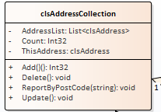
Remember to start your Git Hub day!
Create a new test class tstAddressCollection...
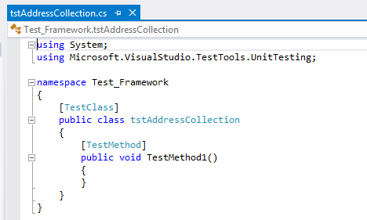
Next create a test to see if we can create an instance of the class...
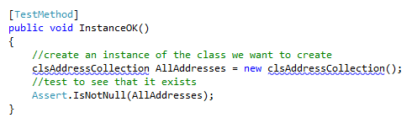
Watch the test fail...
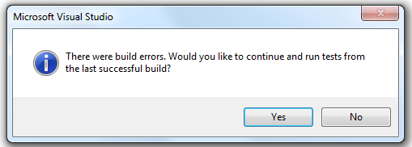

Now fix the test...
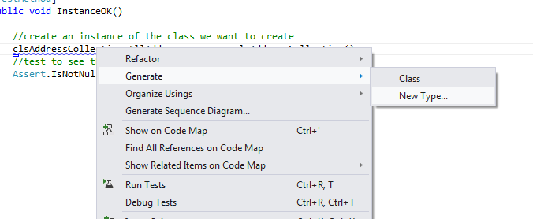

Making sure the new class file is created in the class library...
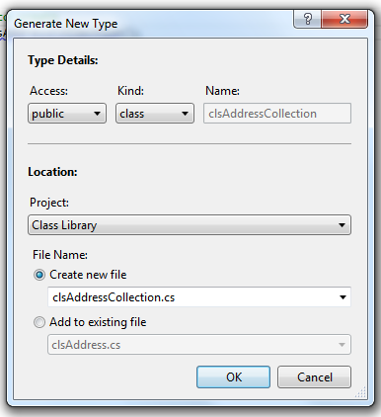
Then see the test pass.

Creating the Properties
Next, we create the properties for the class.
It doesn't matter at this stage what order we create them in so we will use the order on the class diagram:
- AddressList
- Count
- ThisAddress

We need to first import into the class file the .NET library for handling collections...
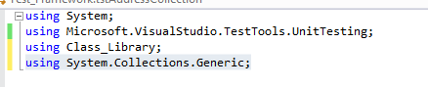
Now we may create the test for the AddressList property...
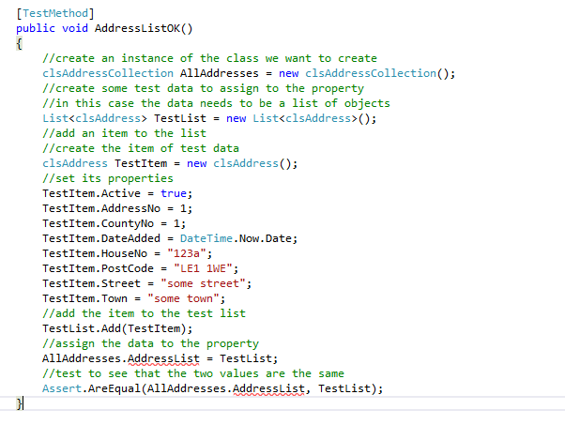
As usual the test should fail...
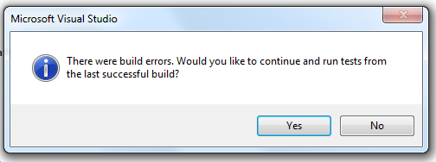
Fix the test to see it pass...

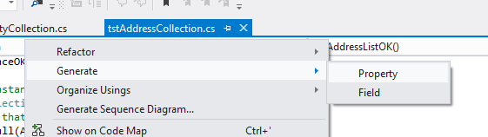
Here are the remaining tests for the other two properties....
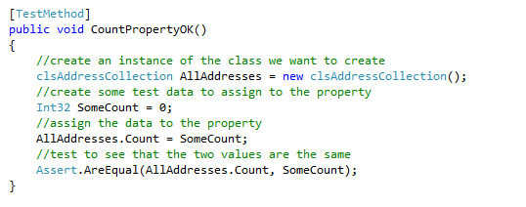
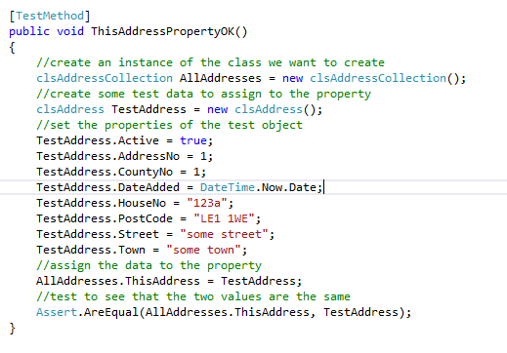
(I will let you sort out the code that generates the two properties!)
We will now set about creating the code that drives the Count property and the AddressList.

Address List and Count
The AddressList will provide us with an indexed list of Address from the database table.
The Count property will always tell us how many addresses there are in this list.
We have already created the tests to make sure the two properties exist so let's spend a little time writing the code to create the functionality.
The first test we shall write is one to test if records can be added to the lists and the Count property correctly reports how many items are in the list.
Here is the test...
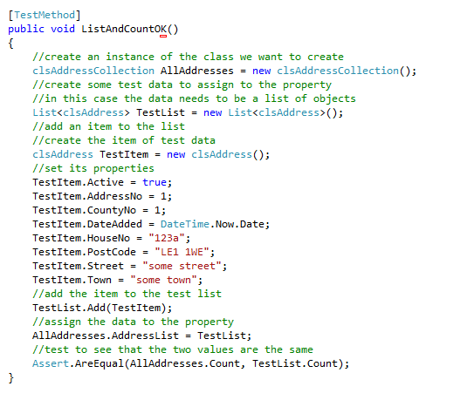
The test creates a test list and adds one record to that list. The AddressList is then assigned to the test list. If everything is working, then both lists should report a count of 1.
This should of course fail...
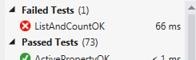
We now need to modify clsAddressCollection.
We need to create a private data member for the list with class level scope at the top of the class...
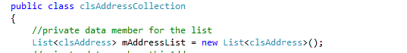
Next, we need to expose the private data via the public property by modifying the auto generated property.
From this…
To this…
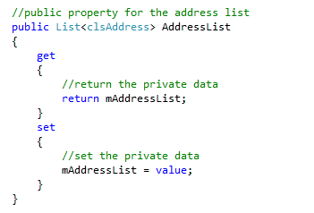
Once that is set up, we may return the value of the Count property of the list as the value of our own Count property.
You will need to change the code for the Count property from this…
To this…
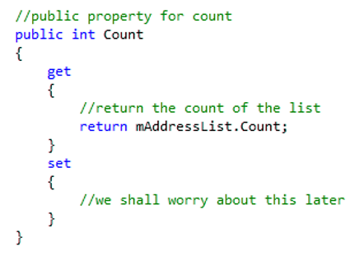
The two properties should now look something like this…
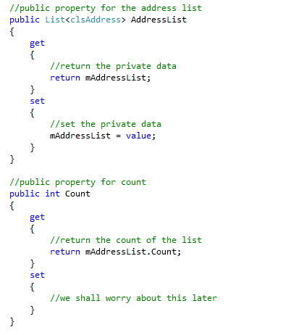
The test should now pass however the code is still rubbish!
Let’s have a think now about what we are trying to do.
The way we want this object to behave is that when we create an instance of the class the list is populated with all the addresses in the database.
However, when we invoke the ReportByPostCode method...
The AddressList should only contain the addresses that match the post code supplied as a filter.
Let's create a test that gets us going in the right direction but will almost certainly be scrapped later.
Take a look at the following test...
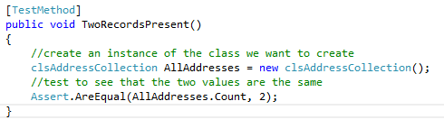
This test assumes that there are always two records in the AllAddresses object upon instantiation.
Clearly this test will fail (as always).
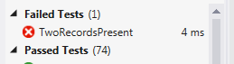

OK - so let's add some code to the class’s constructor.
Like so...
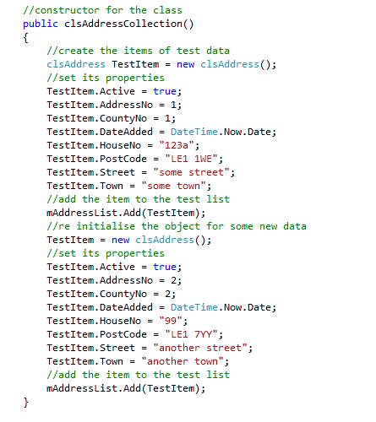
This adds two test records to the private list such that the test for two records now passes.
The bad news is that another test now fails...
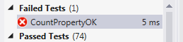
So, what's the problem?
This test...
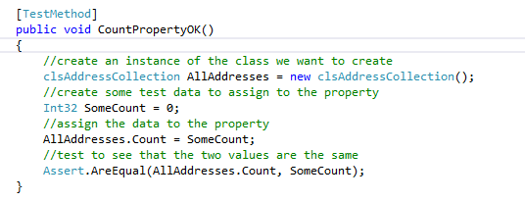
This test assumes that there will always be zero records in the list. This was true until we started adding code to the constructor just now.
We will apply a quick fix to this just to make the test pass like so...
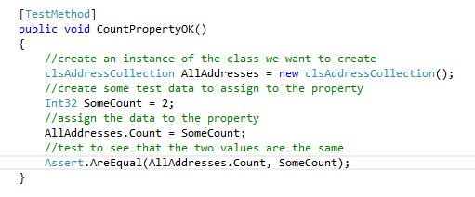
Honestly the code is still rubbish!

Creating the Data Layer
What we really want to be doing here is reading the data from the database rather than hard coding records like this.
Let's assume we have the following data...
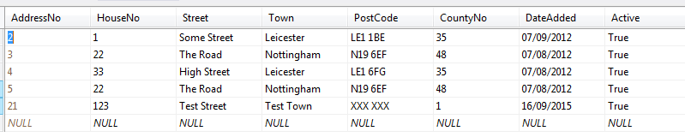
Along with the following stored procedure...
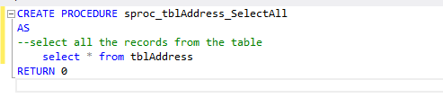
The following code should do the trick...
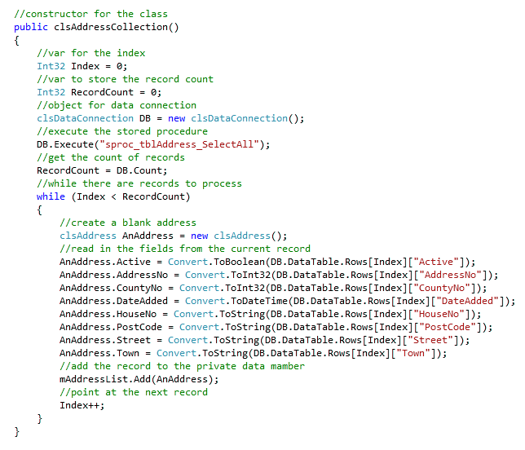
If you run your tests now you should see the following results...
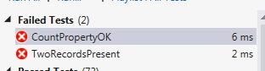
The first problem is that we no longer have a guaranteed two records...
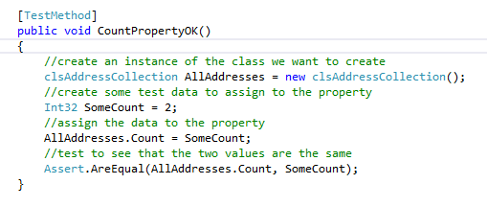
To be honest we could get rid of this test now as it is tested more thoroughly by this test...
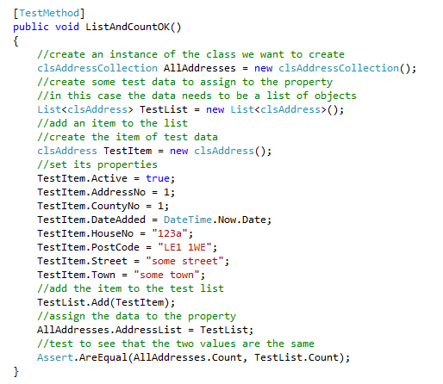

The following test...

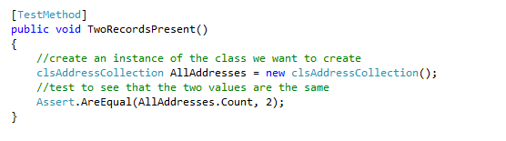
Is also redundant and may be removed.
Getting rid of the two tests above should mean that all the tests pass, and we now have a usable and tested collection class which is ready to be linked to the presentation layer.

Adding the Presentation Layer
As part of the admin system web site you should have a web form called something like AddressBookList.aspx…
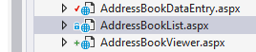
Open the form in design view so that you are in a position to add some controls.
In design view add a list box to the web form…
and name it lstAddressList (lst short for list) like so…
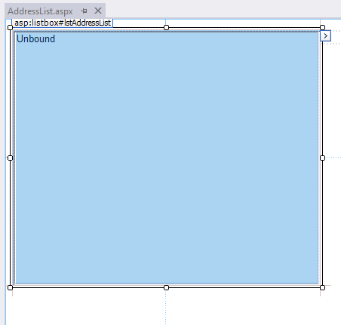

We need to add the following code to the form created above.
Right click on the web form and select view code…
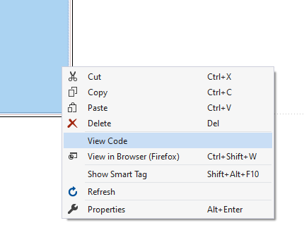
Modify the code for the page from this…
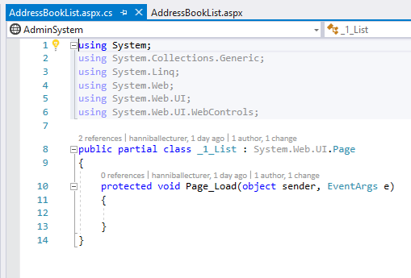
To this…
Add a Using at the top of the class…
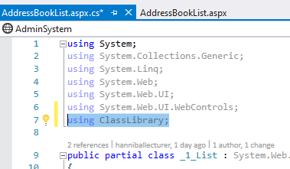
The modify the existing code like so…
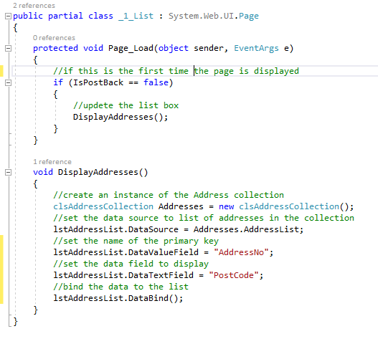
This code should update the list box with a list of post codes.
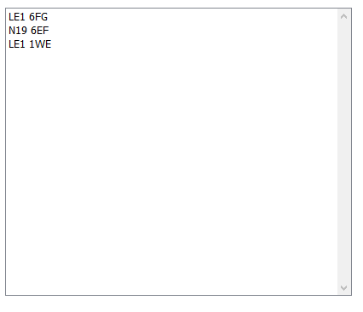
Finally finish off your Git Hub day.

